**Building a Smarter AI-Powered Spam Classifier**

**Introduction**

In the digital age, email communication is ubiquitous, but so are spam messages cluttering inboxes. Traditional spam filters have limitations, prompting the need for smarter solutions. This project aims to develop an advanced AI-powered spam classifier, leveraging cutting-edge machine learning techniques to enhance accuracy and efficiency. By exploring innovative algorithms and datasets, we seek to create a robust system capable of distinguishing between genuine messages and spam, ensuring a seamless and secure email experience for users. This endeavor delves into the intersection of artificial intelligence and cybersecurity, addressing a pressing concern in today’s online landscape.

**Data Collection:**

Gather a large and diverse dataset of emails or messages, labeled as spam or non-spam (ham). This dataset is crucial for training your AI model.

**Data Preprocessing**

Clean and preprocess the data. This may involve tasks like removing special characters, stemming, and tokenization.

**Feature Extraction:**

Extract relevant features from the preprocessed data. Common techniques include Bag-of-Words, TF-IDF (Term Frequency-Inverse Document Frequency), or word embeddings like Word2Vec.

**Choosing a Model:**

Select an appropriate machine learning algorithm or deep learning architecture for your task. Popular choices include Naïve Bayes, Support Vector Machines, or deep learning models like Recurrent Neural Networks (RNNs) or Transformers.

**Training the Model:**

Train your chosen model using the preprocessed data. Use a portion of the dataset for training and another portion for validation to fine-tune the model.

**Evaluation**:

Evaluate the model’s performance using metrics like accuracy, precision, recall, and F1-score. This helps in understanding how well your model is performing.

**Fine-Tuning**:

Based on the evaluation results, fine-tune the model. This could involve adjusting hyperparameters, trying different algorithms, or exploring advanced techniques like ensemble methods.

**Testing and Deployment:**

Test the final model on a separate test dataset to ensure its generalizability. Once you’re confident in its performance, deploy the model into your application or system.

**Monitoring and Maintenance:**

Continuously monitor the model’s performance in real-world scenarios. Spam patterns can change over time, so periodic updates and retraining might be necessary to maintain the classifier’s accuracey.

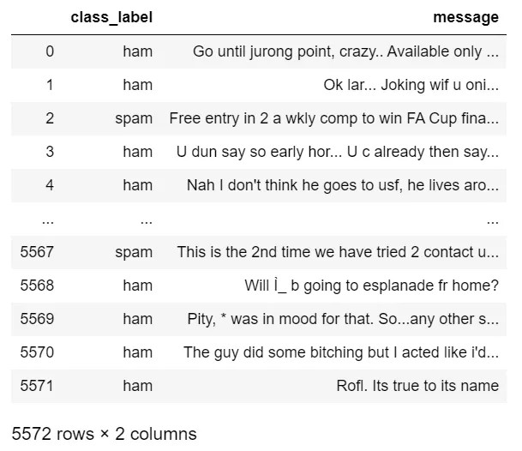

**Code**

Exploratory Data Analysis

Def text_clean(text, method, rm_stop):

Text = re.sub(r”\n”,””,text) #remove line breaks

Text = text.lower() #convert to lowercase

Text = re.sub(r”\d+”,””,text) #remove digits and currencies

Text = re.sub(r’[\$\d+\d+\$]’, “”, text)

Text = re.sub(r’\d+[\.\/-]\d+[\.\/-]\d+’, ‘’, text) #remove dates

Text = re.sub(r’\d+[\.\/-]\d+[\.\/-]\d+’, ‘’, text)

Text = re.sub(r’\d+[\.\/-]\d+[\.\/-]\d+’, ‘’, text)

Text = re.sub(r’[^\x00-\x7f]’,r’ ‘,text) #remove non-ascii

Text = re.sub(r’[^\w\s]’,’’,text) #remove punctuation

Text = re.sub(r’https?:\/\/.*[\r\n]*’, ‘’, text) #remove hyperlinks

#remove stop words

If rm_stop == True:

Filtered_tokens = [word for word in word_tokenize(text) if not word in set(stopwords.words(‘english’))]

Text = “ “.join(filtered_tokens)

#lemmatization: typically preferred over stemming

If method == ‘L’:

Lemmer = WordNetLemmatizer()

Lemm_tokens = [lemmer.lemmatize(word) for word in word_tokenize(text)]

Return “ “.join(lemm_tokens)

#stemming

If method == ‘S’:

Porter = PorterStemmer()

Stem_tokens = [porter.stem(word) for word in word_tokenize(text)]

Return “ “.join(stem_tokens)

**Advantages**

**Improved Accuracy:**

Advanced algorithms can enhance accuracy by identifying subtle patterns in spam messages that might be difficult for traditional methods to detect.

**Adaptability:**

AI classifiers can adapt to new types of spam, evolving with spammers’ tactics to stay effective over time.

**Efficiency**:

Automation reduces the need for manual review, saving time and resources for businesses and users.

**Customization**:

AI models can be fine-tuned to specific needs, allowing for customization based on the type of content and users’ preferences.

**Reduced False Positives:**

Smarter classifiers can minimize the chances of marking legitimate messages as spam, enhancing user experience.

**Real-Time Processing:**

AI systems can process messages in real-time, ensuring timely spam detection and prevention.

**Data Insights:**

Analyzing spam patterns can provide valuable insights into cybersecurity threats and help organizations bolster their overall security measures.

**Cost-Effectiveness**:

While the initial setup might require an investment, the long-term cost savings from reduced manual intervention and improved efficiency can be substantial.

**User Trust:**

Effective spam filtering enhances user trust in online platforms, as they experience a cleaner and safer communication environment.

**Compliance**:

AI-powered classifiers can assist in adhering to data protection laws by efficiently managing and filtering sensitive information in accordance with regulations.

**Disadvantage**

**Overfitting**:

If the AI model is too tailored to the training data, it might perform well on the specific data it was trained on but struggle with new, unseen data.

**Bias**:

AI models can inadvertently learn biases present in the training data, leading to discriminatory outcomes or skewed classifications.

**Resource Intensiveness:**

Training advanced AI models requires significant computational resources, making it resource-intensive, especially for small organizations or individuals.

**Constant Adaptation:**

Spammers constantly evolve their tactics, which means the AI model needs continuous updates and training to stay effective, requiring ongoing effort and resources.

**Complexity**:

Advanced AI models can be complex, making it difficult to interpret their decisions. This lack of transparency might be a concern, especially in critical applications where understanding the decision-making process is crucial.

**Dependency on Data Quality:**

The effectiveness of AI-powered spam classifiers heavily depends on the quality and relevance of the training data. Poor-quality or biased training data can lead to inaccurate classifications.

**Security Concerns:**

AI models, if not properly secured, can be vulnerable to attacks, including adversarial attacks where malicious actors intentionally manipulate input data to deceive the classifier.

**Privacy Concerns:**

Processing user messages to classify spam raises privacy concerns, especially if the content of messages is analyzed without proper consent or safeguards.

**Algorithmic Fairness:**

Ensuring fairness in AI models is challenging, as biases in the training data can lead to unfair treatment of certain groups or individuals.

**Benefits**

**Improved Email Filtering:**

It enhances the accuracy of filtering out unwanted emails, ensuring that users receive only relevant and important messages.

**Time and Productivity:**

Users save time by not having to manually sift through spam emails, leading to increased productivity.

**Enhanced Security:**

Effective spam filtering reduces the risk of phishing attacks and malware, enhancing overall cybersecurity.

**User Experience:**

Users experience a cleaner inbox, leading to higher satisfaction and a better overall email communication experience.

**Cost Efficiency:**

It reduces costs associated with dealing with spam-related issues, such as cybersecurity threats and productivity losses.

**Customization:**

AI-powered classifiers can be tailored to specific user preferences, improving personalization and user satisfaction.

**Data Analysis:**

Analyzing patterns in spam emails can provide valuable insights into emerging trends and help in preemptive security measures.

**Continuous Improvement:**

Machine learning algorithms can learn from new spam patterns, ensuring the system evolves to counter emerging spam techniques.

**Conclusion**

In conclusion, building a smarter AI-powered spam classifier is crucial in today’s digital age to enhance online communication and user experience. By leveraging advanced machine learning algorithms and natural language processing techniques, we can develop more accurate and efficient spam filters. These filters not only help in reducing the annoyance of unsolicited messages but also protect users from phishing attempts and fraudulent activities.

Continuous research and development in the field of artificial intelligence are essential to stay ahead of evolving spam tactics. Collaboration between experts, data scientists, and cybersecurity professionals is pivotal in creating robust and adaptive spam classifiers. Additionally, user feedback and real-time data analysis are vital to refining the algorithms, ensuring they remain effective against emerging spam patterns.